Forums of Arab Municipal Leaders as an Effective Platform for Establishing Collective Impact
The current opportunity for creating institutional structures and platforms that can effectively define and express the interests of the Arab municipalities in Israel is enormous. Injaz believes that it is extremely well-positioned to advance these developments, due to its history of successfully convening forums of mayors and senior officials, the trust and good will it has established within the Arab municipalities, and its track record of success since the passing of the historic federal Resolution 922 in 2016. Arab municipalities represent approximately 35% of the municipalities in Israel, yet they have not successfully established effective platforms for sharing ideas and initiating substantive change.
The next three years will be crucial for building upon and leveraging the successes realized over the past two years. With the proper support, the Arab municipalities can over time arrive at a “tipping point,” where the forward motion is driven by past achievement, is increasingly empowering, and creates shared platforms and institutions for professional dialogue and sustainable development.
The Background
Since shortly after its founding, the Injaz Center for Professional Arab Local Governance has successfully convened and managed important and impactful forums to improve communication and the sharing of ideas among Arab municipal leaders. These forums provide an opportunity to create a unified set of priorities, as well as providing a platform for the shared learning of best practices.
Beginning in 2011, Injaz invited Arab mayors from across the country to meet several times a year for multi-day meetings to discuss, define and refine common challenges and opportunities. Concurrently, meetings of Arab municipal senior officials had been taking place, with the same goal in mind. Beginning in 2018, Injaz brought the mayors and senior officials together for similar gatherings.
These forums have been the principal means through which Injaz has established its influential and solutions-oriented relationship with Arab municipalities. The municipal leaders view these forums as a vital means to formulate a shared agenda and voice, both internally within the Arab municipalities themselves and vis-à-vis the national government. This improved communication and sharing of ideas has resulted in concrete benefits for the municipalities, as well as stimulating a strong desire among the leaders to expand the opportunities these forums have provided.
The enthusiasm of the participants in these forums has been tremendous, and the municipal leaders have clearly stated their desire for more opportunities to tackle increasingly specific issues and to develop plans for addressing those issues. Injaz is interpreting this desire as a mandate to create more, and more effective, such platforms to advance the Arab municipalities’ functioning and overall wellbeing.
A natural platform from which to launch more such forums is presented by Injaz’s longstanding work with the National Council of Arab Mayors, specifically through its sub-committee structure. When the historic federal Resolution 922 was passed in 2016, earmarking some $4 billion for Israel’s Arab municipalities, Injaz was among the non-profits approached by the National Council to leverage this unprecedented opportunity. At that time, the National Council created 11 sub-committees, each of which was to focus on a specific area of concern, such as education, the environment, industrial zones, etc.
Injaz first began working with the Education Sub-Committee in 2016, and has been very active in managing and significantly enhancing its operation, such that this sub-committee is now perceived by both the Arab municipal leaders and the national government as representing the “united voice” of the Arab community on issues pertaining to education. This united voice has resulted in concrete change, including doubling the federal budget allocated for informal education.
An increasingly important focus of Injaz’s work is now being directed to the Energy and Environment Sub-Committee, which represents an area that has historically not been a high priority for Arab municipalities.
The Plan
Injaz sees its work in creating more and more effective forums as central to its mission and an area of significant growth as it looks into the future. These forums are a potentially powerful means by which Arab municipalities can cooperatively organize their priorities, take responsibility for positive change within their communities, and demonstrate to the government that they take these concerns seriously. Indeed, these forums can be an effective platform from which to establish collective impact, which includes creating:
- A common agenda
- Shared measures of success
- Mutually reinforcing activities
- Continuous communication
- A sustainable structure
An emerging level of engagement is forming within the sub-committee themselves. These taskforces provide a further refined level of addressing issues that are of concern. For example, within the Education Sub-Committee, an Informal Education Taskforce has been created which tackles the specific educational issues relevant to informal education. This taskforce is staffed by informal education professionals from the participating municipalities, and has become active and energized over the past two years. Injaz believes that other such taskforces can and should exist within each of the sub-committees, and that it is at the taskforce level that the most detailed outlining of targeted strategic thinking and planning will take place.
Currently, these forums and taskforces remain very dependent on Injaz’s staffing and management efforts. The goal is that over time they will be self-sustaining and that Injaz will take on more of a consultative role, thus freeing up its resources to move to activate additional forums. The expectation is that gradually the municipalities will take responsibility for the forums, appointing municipal officials from across their communities to manage and sustain them.
With that in mind, Injaz intends in the next three years to invest significantly in strengthening these forums’ operation. Specific planning and solution generation will come from the task forces and those recommendations will make their way back to the respective sub-committees, where a policy recommendation can then be formulated. In this way, an existing and sustainable platform has been created that can more effectively reflect the interests of Arab municipalities and bring about real change.
The Model
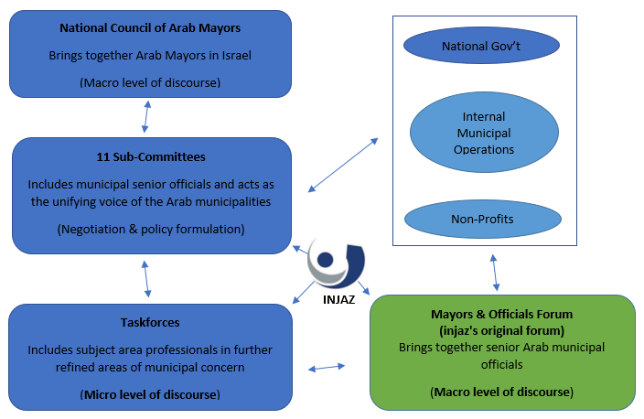

Looking Forward
At the end of 2018, Arab municipalities will hold their local elections. In early to mid-2019, after new leaders have assumed their roles, Injaz will take steps to encourage the National Council to appoint chairpersons of each of the eleven standing sub-committees. These individuals will, over time, be empowered to assume responsibility for their sub-committee’s effective functioning. Injaz will continue to support the sub-committees’ activities, and will assist with recruiting professionals from the municipalities to staff them and the taskforces that constitute them.
The development and expansion stages of activating these platforms can be summarized as follows:
Stage I: Original Injaz forums of senior Arab municipal officials
Stage II: Pilot of sub-committees as a new iteration of the Injaz forums
- Education Sub-Committee
Stage III: Expansion of sub-committees and taskforces
Current Stage
- Education Sub-Committee
  - Informal Education Taskforce
- Energy and Environment Sub-Committee
Stage IV: These platforms are sustainable and managed by municipal officials and Injaz continues to activate additional such forums

The sub-committees of the National Council of Arab Mayors is just one existing platform that can be developed to effectively bring about meaningful change in Israel’s Arab society. Because Injaz has a long-standing relationship with the National Council, this is a natural place to advance such efforts. The potential for building upon successes in this particular platform is enormous, and can over time be replicated to positively impact other bodies, both existing and new.

